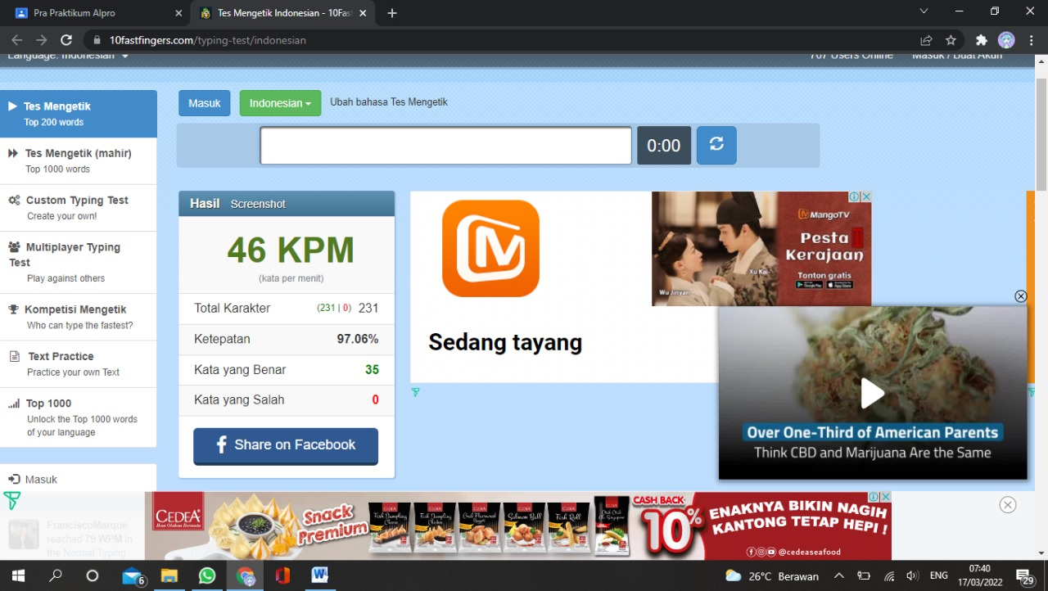

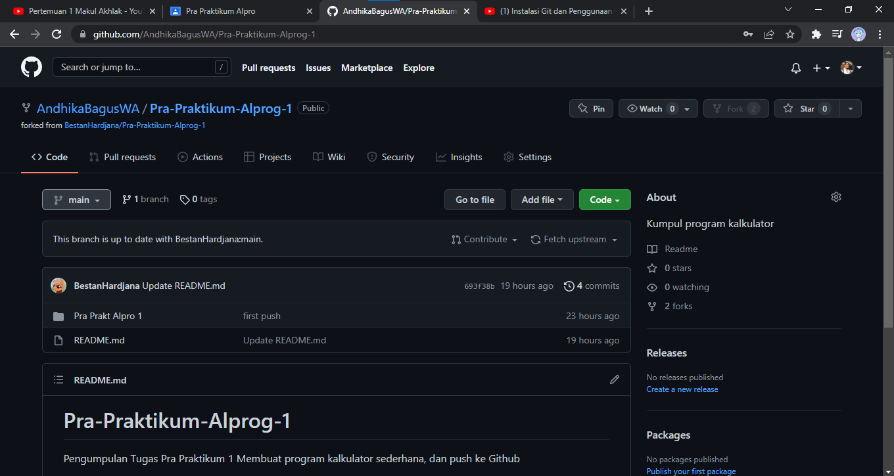

Link : <https://github.com/AndhikaBagusWA/Pra-Praktikum-Alprog-1.git>